

**Semester One**

**Examination 2022**

**Question/Answer booklet**

**HUMAN BIOLOGY**

**UNIT 1**

Name: _______________________________________________________

Teacher: ___________________________________________________

**Time allowed for this paper**

Reading time before commencing work: ten minutes

Working time: two and a half hours

**Materials required/recommended for this paper**

***To be provided by the supervisor***

This Question/Answer booklet

Multiple-choice answer sheet

***To be provided by the candidate***

Standard items: pens (blue/black preferred), pencils (including coloured), sharpener, correction fluid/tape, eraser, ruler, highlighters

Special items: up to three calculators, which do not have the capacity to create or store programmes or text, are permitted in this ATAR course examination

***Important notice to candidates***

No other items may be taken into the examination room. It is **your** responsibility to ensure that you do not have any unauthorised material. If you have any unauthorised material with you, hand it to the supervisor **before** reading any further.

**Structure of this paper**

|  |  |  |  |  |  |
| --- | --- | --- | --- | --- | --- |
| Section | Number of questions available | Number of questions to be answered | Suggested working time  (minutes) | Marks available | Percentage of examination |
| Section One  Multiple-choice | 25 | 25 | 30 | 25 | 30 |
| Section Two  Short answer | 7 | 7 | 80 | 90 | 50 |
| Section Three:  Extended Answer | 2 | 1 | 40 | 20 | 10 |
| 1 | 1 | 15 | 10 |
|  |  |  | **Total** | 150 | 100 |

**Instructions to candidates**

1. The rules for the conduct of Western Australian external examinations are detailed in the *Year 12 Information Handbook 2022: Part II Examinations.* Sitting this examination implies that you agree to abide by these rules.
2. Write your answers in this Question/Answer booklet preferably using a blue/black pen. Do not use erasable or gel pens.
3. Answer the questions according to the following instructions.

Section One: Answer all questions on the separate Multiple-choice answer sheet provided. For each question, shade the box to indicate your answer. Use only a blue or black pen to shade the boxes. Do not use erasable or gel pens. If you make a mistake, place a cross through that square, then shade your new answer. Do not erase or use correction fluid/tape. Marks will not be deducted for incorrect answers. No marks will be given if more than one answer is completed for any question.

Section Two: Write your answers in this Question/Answer booklet. Wherever possible, confine your answers to the line spaces provided.

Section Three: Consists of two parts each with two questions. You must answer one question from each part. Tick the box next to the question you are answering. Write your answers in this Question/Answer booklet.

1. You must be careful to confine your responses to the specific questions asked and follow any instructions that are specific to a particular question.
2. Supplementary pages for planning/continuing your answers to questions are provided at the end of this Question/Answer booklet. If you use these pages to continue an answer, indicate at the original answer where the answer is continued, i.e. give the page number.

**Section One: Multiple-choice 30% (25 Marks)**

This section has **25** questions. Answer **all** questions on the separate Multiple-choice answer sheet provided. For each question, shade the box to indicate your answer. Use only a blue or black pen to shade the boxes. Do not use erasable or gel pens. If you make a mistake, place a cross through that square, then shade your new answer. Do not erase or use correction fluid/tape. Marks will not be deducted for incorrect answers. No marks will be given if more than one answer is completed for any question.

Suggested working time: 30 minutes.

_________________________________________________________________________________

1. There are upward of 600 million alveoli in the human body, producing a surface area of over 75 square metres, roughly the size of a tennis court. Which of the following is the **best** explanation for this large surface area?

1. large amounts of gas can be exchanged in a short time
2. maintains a constant concentration gradient
3. gas molecules do not have to travel a long distance
4. lowers surface tension within the alveoli

2. Which of the following causes the colour of yellow bone marrow?

1. leucocytes
2. blood vessels
3. stored fat
4. developing red blood cells

3. Which of the following lifestyle changes may a doctor suggest to a young woman as a way to prevent the development of osteoporosis?

1. decrease weight-bearing exercise
2. increase dietary intake of calcium
3. begin taking the oral contraceptive pill
4. have a low BMI (body mass index)

4. Which of the following correctly identifies the main characteristics of smooth muscle?

1. striated, branched, uni-nucleated
2. striated, unbranched, multi-nucleated
3. non-striated, branched, multi-nucleated
4. non-striated, unbranched, uni-nucleated

5. The plasma membrane that surrounds a muscle fibre is known as the

1. sarcolemma.
2. endomysium.
3. sarcoplasmic reticulum.
4. fascia.

6. Which of the following is **not** a property of muscles?

1. extendibility
2. elasticity
3. extensibility
4. contractibility

7. Smoking cigarettes can lead to the paralysis of cilia found in the airways. Which of the following **best** explains why this paralysis causes smokers cough?

1. Air trapped in the airways becomes humidified, triggering the cough reflex
2. Mucus collects, trigger a cough reflex in attempt to remove it
3. Paralysis of cilia triggers release of neurotransmitters that cause coughing
4. The lumen (diameter) of the airways decreases, requiring coughs to expel the air

8. Which of the following is true regarding bile?

1. Bile consists of enzymes associated with catabolic reactions.
2. Bile is formed in the gall bladder and stored in the liver.
3. Bile is associated with the chemical digestion of lipids.
4. Bile is released into the small intestine.

9. Which of the following is **not** part of the axial skeleton?

1. skull
2. ribs
3. pelvic girdle
4. Vertebrae

10. A fractured nose can be the result of a break in either the bone or the cartilage of the nose. What type of cartilage is found in the nose?

1. hyaline cartilage
2. fibrocartilage
3. elastic cartilage
4. smooth cartilage

Question 11 refers to the set of four graphs shown below.

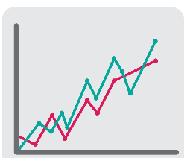 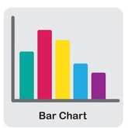 

**Graph A Graph B Graph C Graph D**

11. Which of the following does **not** match the type of graph that would be used with the given experiment?

1. Graph A; The effect of varying amounts of caffeine on urine output
2. Graph B; The height distribution of students in Year 11 at a High School
3. Graph C; The rates of cancer in Australia over a 10 year period
4. Graph D; The blood types of 25 different donors

12. Sorbitol, a sugar alternative, contains one third the number of calories of sugar. Labels on food packets containing sorbitol are found with warnings of laxative effects following overconsumption, due the osmotic nature of the chemical. In which of the following organs does sorbitol act to cause diarrhoea?

1. small intestine
2. stomach
3. large intestine
4. kidneys

Question 13 refers to the results of an agglutination test of a blood sample shown in the image below. The blood sample was mixed with A and B antibodies.

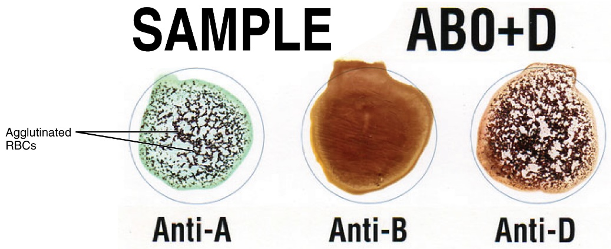

13. The blood type of the sample shown above is

1. Type A.
2. Type B.
3. Type AB.
4. Type O.

14. A patient with blood Type O

1. has both types of antibodies in their blood and can receive any other blood type.
2. lacks antigens on their erythrocytes and can donate to all other blood types.
3. has both types of antigens in their blood and can receive any other blood type.
4. lacks antibodies on their erythrocytes and can donate to all other blood types.

15. When undertaking experiments using mice, animal ethics must be considered. The National Health and Medical Research Council provides a code by which animals can be used for scientific purposes. This code

1. helps scientists choose the species of animal to conduct science experiments on.
2. promotes the skills of scientists in the fields of ethical and responsible animal care.
3. reassures scientists that using animals in science is not a bad thing.
4. allows scientists to understand how to look after animals being used scientifically.

Questions 16 and 17 refer to the diagram of the kidney below.

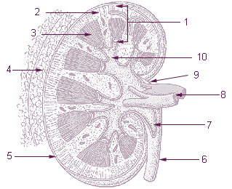

16. The structure identified at Location 3 is known as the

1. renal column.
2. renal pyramid.
3. renal cortex.
4. renal pelvis.

17. The microscopic functional unit of the kidney can be found at

1. Location 2
2. Location 5
3. Location 8
4. Location 10

18. Which of the following lists of substrates would you **not** expect to find in the filtrate contained within the Bowman’s capsule in normal conditions?

1. amino acids and glucose
2. urea and creatinine
3. proteins
4. salts

19. The main function of the Loop of Henle is

1. the reabsorption of water and salt.
2. filtration of blood.
3. secretion of metabolic wastes.
4. formation of urine.

20. In 2016, a study showed that a diet lacking in zinc showed impairment of the pancreatic digestive enzymes in weaned piglets. Zinc is important in the diet because it

1. acts as a coenzyme for certain digestive enzymes.
2. inhibits the overproduction of digestive enzymes.
3. acts as a cofactor for certain digestive enzymes.
4. is a substrate for digestive enzymes.

21. The tissue type that passes electrochemical signals to all parts of the body is known as

1. muscular tissue.
2. nervous tissue.
3. connective tissue.
4. epithelial tissue.

22. The cardiac muscle tissue of the heart is branched. The **best** reason for these branches is

1. they allow for the larger size of the heart needing to contract all at once.
2. they allow for the quick transmission of signals needed for heart contractions.
3. they have densely packed myofibrils to allow for fast contractions.
4. cardiac muscle is not organised into sarcomeres.

23. Pepsin, a type of protease, is an enzyme found in the digestive system. Which of the following correctly identifies the location and optimal pH for this enzyme?

1. stomach, pH of 1.5 – 2.0
2. small intestine, pH of 7.5 – 8.0
3. stomach, pH of 7.5 – 8.0
4. small intestine, pH of 1.5 – 2.0

24. Joints are described by how much movement they allow. A joint where two or more bones are connected by cartilage, and held tightly so that limited movement can occur, is known as a

1. freely moveable joint.
2. slightly moveable joint.
3. immovable joint.
4. synovial joint.

Question 25 refers to the histological image of a type of cartilage below.

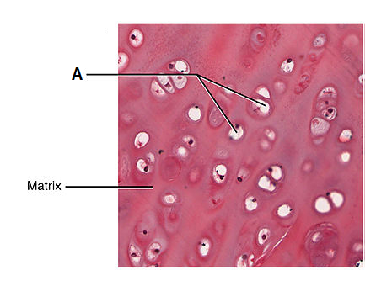

25. The structures labelled as ‘A’ are

1. osteons within hyaline cartilage.
2. blood vessels within elastic cartilage.
3. collagen fibres within fibrocartilage.

(d) chondrocytes within hyaline cartilage.

**End of Section One**

**This page has been left blank intentionally**

**Section Two: Short answer 50% (90 Marks)**

This section has **seven** questions. Answer **all** questions. Write your answers in the spaces provided.

Supplementary pages for planning/continuing your answers to questions are provided at the end of this Question/Answer booklet. If you use these pages to continue an answer, indicate at the original answer where the answer is continued, i.e. give the page number.

Suggested working time: 80 minutes.

_________________________________________________________________________________

**Question 26 (14 marks)**

1. Aortic valve stenosis, where the valve is unable to fully open, is one of many congenital birth defects and can cause failure to thrive in children. State where this valve is located and explain the effect this condition would have on blood flow through the heart.

(3 marks)

___________________________________________________________________________

___________________________________________________________________________

___________________________________________________________________________

___________________________________________________________________________

___________________________________________________________________________

1. Lifestyle choices can compromise the functioning of the human body. Describe how a person’s diet can impact their circulatory system.

(3 marks)

___________________________________________________________________________

___________________________________________________________________________

___________________________________________________________________________

___________________________________________________________________________

___________________________________________________________________________

Below is a magnified image showing the lining of a blood vessel.

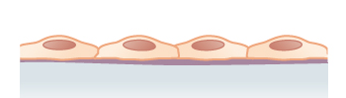

1. Identify the tissue type shown above and briefly describe how its structure allows for effective exchange of gases.

(4 marks)

___________________________________________________________________________

___________________________________________________________________________

___________________________________________________________________________

___________________________________________________________________________

___________________________________________________________________________

___________________________________________________________________________

1. Draw a labelled diagram in the space below to contrast the structural differences between arteries and veins.

(4 marks)

|  |
| --- |
|  |

**Question 27 (14 marks)**

1. Explain how muscles of the chest area are involved in the process of inspiration.

(4 marks)

___________________________________________________________________________

___________________________________________________________________________

___________________________________________________________________________

___________________________________________________________________________

___________________________________________________________________________

___________________________________________________________________________

Below is a diagram of the respiratory system.

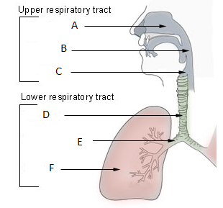

1. Identify the structures located at (2 marks)

D __________________________

E __________________________

1. Explain why mucus would be found in the structure identified by the letter D.

(2 marks)

___________________________________________________________________________

___________________________________________________________________________

___________________________________________________________________________

___________________________________________________________________________

___________________________________________________________________________

1. Differentiate between the types of cartilage found in the epiglottis and the trachea, and state why these types of cartilage are present in these structures.

(6 marks)

___________________________________________________________________________

___________________________________________________________________________

___________________________________________________________________________

___________________________________________________________________________

___________________________________________________________________________

___________________________________________________________________________

___________________________________________________________________________

___________________________________________________________________________

___________________________________________________________________________

___________________________________________________________________________

**Question 28 (12 marks)**

Floppy baby syndrome is a way of describing a newborn baby with low muscle tone, known as hypotonia.

1. Describe how muscle tone is related to posture.

(3 marks)

___________________________________________________________________________

___________________________________________________________________________

___________________________________________________________________________

___________________________________________________________________________

___________________________________________________________________________

1. Strengthening of support muscles is a treatment for low muscle tone. When exercising, it is important that resistance is used during both extension and flexion of the arm. Explain the reason for this.

(2 marks)

___________________________________________________________________________

___________________________________________________________________________

___________________________________________________________________________

___________________________________________________________________________

Due to the side effects of anabolic steroids, the use of them in Australia is legal only when prescribed by a doctor for proper medical reasons. Athletes sometimes take anabolic steroids illegally to improve their athletic performance. In young people, particularly those whose bones have not yet fully developed, this can speed up the process of cartilage becoming bone.

1. Describe what the term ‘anabolic’ means.

(2 marks)

___________________________________________________________________________

___________________________________________________________________________

___________________________________________________________________________

1. Outline how consumption of anabolic steroids may impact the bone growth and height of a young person.

(3 marks)

___________________________________________________________________________

___________________________________________________________________________

___________________________________________________________________________

___________________________________________________________________________

___________________________________________________________________________

1. Another health consequence of anabolic steroids is the stiffening of tendons. What is the function of a tendon and how could this impact the athlete’s performance?

(2 marks)

___________________________________________________________________________

___________________________________________________________________________

___________________________________________________________________________

___________________________________________________________________________

**Question 29 (11 marks)**

1. Define the term ‘digestion’ and state how it is different to ‘metabolism’.

(2 marks)

___________________________________________________________________________

___________________________________________________________________________

___________________________________________________________________________

___________________________________________________________________________

The diagram below illustrates a section of the alimentary canal.

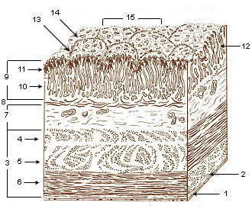

1. Identify the organ to which the section shown in the diagram above belongs.

(1 mark)

___________________________________________________________________________

1. Name **one** specific cell that you would find in the epithelial area labelled 9 and give the function of the product it secretes.

(2 marks)

___________________________________________________________________________

___________________________________________________________________________

___________________________________________________________________________

1. Outline how the layers of muscles, identified throughout location 3 in the diagram, aid in the forward movement of the bolus in the digestive system.

(3 marks)

___________________________________________________________________________

___________________________________________________________________________

___________________________________________________________________________

___________________________________________________________________________

___________________________________________________________________________

___________________________________________________________________________

Pancreatic cancer patients often show many signs of digestive disturbance, with weight loss and a decrease in appetite quite common.

1. Account for the loss of weight in pancreatic cancer sufferers.

(3 marks)

___________________________________________________________________________

___________________________________________________________________________

___________________________________________________________________________

___________________________________________________________________________

___________________________________________________________________________

___________________________________________________________________________

**Question 30 (12 marks)**

Excretion applies to the metabolic waste products that cross the cell membrane. The cell membrane is described as a phospholipid bilayer.

1. Describe why phospholipids organise themselves into a bilayer in the presence of water.

(2 marks)

___________________________________________________________________________

___________________________________________________________________________

___________________________________________________________________________

___________________________________________________________________________

1. State whether the layers of the plasma membrane bilayer are identical to each other. Give a reason for your answer.

(2 marks)

___________________________________________________________________________

___________________________________________________________________________

___________________________________________________________________________

___________________________________________________________________________

1. Why do metabolic wastes need to be excreted from the cells of the body?

(3 marks)

___________________________________________________________________________

___________________________________________________________________________

___________________________________________________________________________

___________________________________________________________________________

An experiment was undertaken to record the amount of sweat lost over a 60-minute exercise session. The results are shown in the diagram below.

1. Although primarily used for temperature regulation, name **two** metabolic wastes the sweat glands excrete.

(2 marks)

___________________________________________________________________________

___________________________________________________________________________

1. The experiment on sweat rate does not include any controlled variables. Give a reason why conclusions from such experiments are undesirable in the scientific community and describe how you would include a control variable.

(3 marks)

___________________________________________________________________________

___________________________________________________________________________

___________________________________________________________________________

___________________________________________________________________________

___________________________________________________________________________

___________________________________________________________________________

**Question 31 (14 marks)**

Bone cells compose less than 2% of the bone mass. The types of cells found within the bone are shown below.

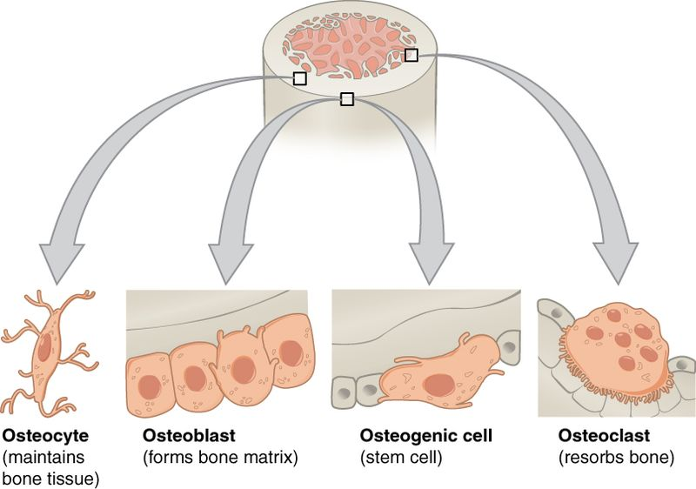

1. What function do osteoblasts serve and where would you find these cells within the bone?

(2 marks)

___________________________________________________________________________

___________________________________________________________________________

___________________________________________________________________________

___________________________________________________________________________

1. Explain how the cellular projections of the osteocyte allow bone cells to communicate.

(3 marks)

___________________________________________________________________________

___________________________________________________________________________

___________________________________________________________________________

___________________________________________________________________________

___________________________________________________________________________

___________________________________________________________________________

**Question 31** (continued)

1. Most bones contain both spongy and compact tissue. Identify **three** differences between these types of tissue.

(3 marks)

___________________________________________________________________________

___________________________________________________________________________

___________________________________________________________________________

___________________________________________________________________________

___________________________________________________________________________

___________________________________________________________________________

The site where two bones connect is known as a joint. The image below shows the sagittal view of an elbow joint.

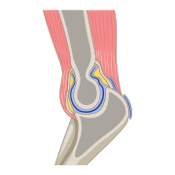

1. Identify the type of synovial joint located at the elbow and state the **two** movements which take place at this type of joint.

(3 marks)

___________________________________________________________________________

___________________________________________________________________________

___________________________________________________________________________

___________________________________________________________________________

1. Movement of joints occurs frequently. Describe how the structure of the synovial joint allows for continuous use with minimal damage.

(3 marks)

___________________________________________________________________________

___________________________________________________________________________

___________________________________________________________________________

___________________________________________________________________________

___________________________________________________________________________

___________________________________________________________________________

**Question 32 (13 marks)**

A 53-year-old woman began complaining of a dull ache in her left arm and presented with a pale, sweaty face to the first aid station at the Perth Royal Show. The paramedics suspected that she was suffering a myocardial infarction (heart attack), and an ambulance was called. Whilst waiting for the ambulance, the woman was given an oxygen mask and an injection of an isotonic solution into the vein.

1. Explain why the patient was given a supply of oxygen.

(3 marks)

___________________________________________________________________________

___________________________________________________________________________

___________________________________________________________________________

___________________________________________________________________________

___________________________________________________________________________

___________________________________________________________________________

1. Explain how the injection of isotonic solution will affect the patient’s extracellular fluid volume. (3 marks)

___________________________________________________________________________

___________________________________________________________________________

___________________________________________________________________________

___________________________________________________________________________

___________________________________________________________________________

___________________________________________________________________________

1. Following the 53-year-old patient’s suspected heart attack, her doctor noticed the site of the intravenous injection was red and inflamed. The doctor proceeded to check the size of the patient’s lymph nodes in her armpit. Explain why this was done.

(2 marks)

___________________________________________________________________________

___________________________________________________________________________

___________________________________________________________________________

___________________________________________________________________________

The human body is made predominantly of water. The diagram below shows the water content as a percentage of the different organs of the body.

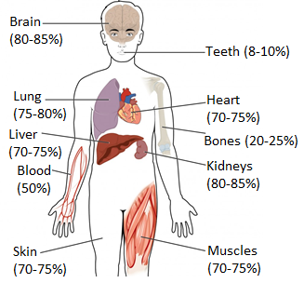

1. Account for the higher percentage of water found in the lungs.

(2 marks)

___________________________________________________________________________

___________________________________________________________________________

___________________________________________________________________________

___________________________________________________________________________

**Question 32** (continued)

Some of the fluid found within the circulatory system is forced out due to the high pressure of blood entering the capillary beds and is then returned via the lymphatic system.

1. Contrast the lymphatic and circulatory systems.

(3 marks)

___________________________________________________________________________

___________________________________________________________________________

___________________________________________________________________________

___________________________________________________________________________

___________________________________________________________________________

___________________________________________________________________________

___________________________________________________________________________

**End of Section Two**

**This page has been left blank intentionally**

**Section Three: Extended answer 20% (35 Marks)**

This section contains **three** questions. You must answer **two** questions.

Questions 33 and 34 are from Part 1. Question 35 forms Part 2. Answer **one** question from Part 1 and the **one** question from Part 2.

Responses could include clearly labelled diagrams with explanatory notes; lists of points with linking sentences; clearly labelled tables and graphs; and annotated flow diagrams with introductory notes.

Supplementary pages for planning/continuing your answers to questions are provided at the end of this Question/Answer booklet. If you use these pages to continue an answer, indicate at the original answer where the answer is continued, i.e. give the page number.

Suggested working time: 50 minutes.

_________________________________________________________________________________

**Part 1**

Choose **either** Question 33 **or** Question 34.

Indicate the question you will answer by ticking the box next to the question. Write your answer on pages 34–38. When you have answered your first question, turn to page 39 and indicate on that page the second question you will answer.

**Question 33 (20 marks)**

1. Proteins are large, complex molecules that play a variety of critical roles in the human body. Briefly describe the composition of proteins, and outline how each of a cell’s organelles are associated with proteins.

(12 marks)

1. Cellular respiration can be undertaken in both the presence and absence of oxygen. Outline the process of respiration which occurs when oxygen **is** present.

(8 marks)

**Question 34 (20 marks)**

1. Blood is made up of plasma and formed elements, with 45% of blood being composed of cells and fragments of cells. Briefly describe the structure and function of the formed elements within blood.

(12 marks)

1. Nutrients, found circulating in the blood, must first be absorbed through the digestive tract. Explain how nutrients are absorbed in the small intestine.

(8 marks)

Question number: _______________

___________________________________________________________________________________________________________________________________________________________________________________________________________________________________________________________________________________________________________________________________________________________________________________________________________________________________________________________________________________________________________________________________________________________________________________________________________________________________________________________________________________________________________________________________________________________________________________________________________________________________________________________________________________________________________________________________________________________________________________________________________________________________________________________________________________________________________________________________________________________________________________________________________________________________________________________________________________________________________________________________________________________________________________________________________________________________________________________________________________________________________________________________________________________________________________________________________________________________________________________________________________________________________________________________________________________________________________________________________________________________________________________________________________________________________________________________________________________________________________________________________________________________________________________________________________________________________________________________________________________________________________________________________________________________________________________________________

Question number: _______________

__________________________________________________________________________________________________________________________________________________________________________________________________________________________________________________________________________________________________________________________________________________________________________________________________________________________________________________________________________________________________________________________________________________________________________________________________________________________________________________________________________________________________________________________________________________________________________________________________________________________________________________________________________________________________________________________________________________________________________________________________________________________________________________________________________________________________________________________________________________________________________________________________________________________________________________________________________________________________________________________________________________________________________________________________________________________________________________________________________________________________________________________________________________________________________________________________________________________________________________________________________________________________________________________________________________________________________________________________________________________________________________________________________________________________________________________________________________________________________________________________________________________________________________________________________________________________________________________________________________________________________________________

Question number: _______________

_____________________________________________________________________________________________________________________________________________________________________________________________________________________________________________________________________________________________________________________________________________________________________________________________________________________________________________________________________________________________________________________________________________________________________________________________________________________________________________________________________________________________________________________________________________________________________________________________________________________________________________________________________________________________________________________________________________________________________________________________________________________________________________________________________________________________

______________________________________________________________________________________________________________________________________________________________________________________________________________________________________________________________________________________________________________________________________________________________________________________________________________________________________________________________________________________________________________________________________________________________________________________________________________________________________________________________________________________________________________________________________________________________________________________________________________________________________________________________________________________________________________________________________________________________________________________________________________________________________________________________________________________________________________________________________________________________________________

Question number: _______________

__________________________________________________________________________________________________________________________________________________________________________________________________________________________________________________________________________________________________________________________________________________________________________________________________________________________________________________________________________________________________________________________________________________________________________________________________________________________________________________________________________________________________________________________________________________________________________________________________________________________________________________________________________________________________________________________________________________________________________________________________________________________________________________________________________________________________________________________________________________________________________________________________________________________________________________________________________________________________________________________________________________________________________________________________________________________________________________________________________________________________________________________________________________________________________________________________________________________________________________________________________________________________________________________________________________________________________________________________________________________________________________________________________________________________________________________________________________________________________________________________________________________________________________________________________________________________________________________________________________________________________________________

Question number: _______________

___________________________________________________________________________________________________________________________________________________________________________________________________________________________________________________________________________________________________________________________________________________________________________________________________________________________________________________________________________________________________________________________________________________________________________________________________________________________________________________________________________________________________________________________________________________________________________________________________________________________________________________________________________________________________________________________________________________________________________________________________________________________________________________________________________________________________________________________________________________________________________________________________________________________________________________________________________________________________________________________________________________________________________________________________________________________________________________________________________________________________________________________________________________________________________________________________________________________________________________________________________________________________________________________________________________________________________________________________________________________________________________________________________________________________________________________________________________________________________________________________________________________________________________________________________________________________________________________________________________________________________________________________________________________________________________________________________

**Part 2**

Question 35.

Write your answer on the pages provided.

**Question 35 (15 marks)**

Haemodialysis is a treatment for kidney disease in which external equipment is used to mimic the function of the kidneys. The patient’s blood is passed through artificial membranes within a machine, with dialysis fluid running as a counter-current flow next to the blood.

1. Explain why the patient’s blood and dialysis fluid are passed by each other in opposite directions.

(3 marks)

1. Unlike other metabolites, amino acids are unable to be stored in the human body for later use. Outline the steps required in order to remove these excess amino acids, ensuring you refer to the processes occurring within both the liver and kidneys.

(12 marks)

**End of Questions**

Question number: _______________

___________________________________________________________________________________________________________________________________________________________________________________________________________________________________________________________________________________________________________________________________________________________________________________________________________________________________________________________________________________________________________________________________________________________________________________________________________________________________________________________________________________________________________________________________________________________________________________________________________________________________________________________________________________________________________________________________________________________________________________________________________________________________________________________________________________________________________________________________________________________________________________________________________________________________________________________________________________________________________________________________________________________________________________________________________________________________________________________________________________________________________________________________________________________________________________________________________________________________________________________________________________________________________________________________________________________________________________________________________________________________________________________________________________________________________________________________________________________________________________________________________________________________________________________________________________________________________________________________________________________________________________________________________________________________________________________________________

Question number: _______________

__________________________________________________________________________________________________________________________________________________________________________________________________________________________________________________________________________________________________________________________________________________________________________________________________________________________________________________________________________________________________________________________________________________________________________________________________________________________________________________________________________________________________________________________________________________________________________________________________________________________________________________________________________________________________________________________________________________________________________________________________________________________________________________________________________________________________________________________________________________________________________________________________________________________________________________________________________________________________________________________________________________________________________________________________________________________________________________________________________________________________________________________________________________________________________________________________________________________________________________________________________________________________________________________________________________________________________________________________________________________________________________________________________________________________________________________________________________________________________________________________________________________________________________________________________________________________________________________________________________________________________________________

Question number: _______________

_____________________________________________________________________________________________________________________________________________________________________________________________________________________________________________________________________________________________________________________________________________________________________________________________________________________________________________________________________________________________________________________________________________________________________________________________________________________________________________________________________________________________________________________________________________________________________________________________________________________________________________________________________________________________________________________________________________________________________________________________________________________________________________________________________________________________

______________________________________________________________________________________________________________________________________________________________________________________________________________________________________________________________________________________________________________________________________________________________________________________________________________________________________________________________________________________________________________________________________________________________________________________________________________________________________________________________________________________________________________________________________________________________________________________________________________________________________________________________________________________________________________________________________________________________________________________________________________________________________________________________________________________________________________________________________________________________________________

Question number: _______________

__________________________________________________________________________________________________________________________________________________________________________________________________________________________________________________________________________________________________________________________________________________________________________________________________________________________________________________________________________________________________________________________________________________________________________________________________________________________________________________________________________________________________________________________________________________________________________________________________________________________________________________________________________________________________________________________________________________________________________________________________________________________________________________________________________________________________________________________________________________________________________________________________________________________________________________________________________________________________________________________________________________________________________________________________________________________________________________________________________________________________________________________________________________________________________________________________________________________________________________________________________________________________________________________________________________________________________________________________________________________________________________________________________________________________________________________________________________________________________________________________________________________________________________________________________________________________________________________________________________________________________________________

Question number: _______________

___________________________________________________________________________________________________________________________________________________________________________________________________________________________________________________________________________________________________________________________________________________________________________________________________________________________________________________________________________________________________________________________________________________________________________________________________________________________________________________________________________________________________________________________________________________________________________________________________________________________________________________________________________________________________________________________________________________________________________________________________________________________________________________________________________________________________________________________________________________________________________________________________________________________________________________________________________________________________________________________________________________________________________________________________________________________________________________________________________________________________________________________________________________________________________________________________________________________________________________________________________________________________________________________________________________________________________________________________________________________________________________________________________________________________________________________________________________________________________________________________________________________________________________________________________________________________________________________________________________________________________________________________________________________________________________________________________

Supplementary pages

Question number: _______________

__________________________________________________________________________________________________________________________________________________________________________________________________________________________________________________________________________________________________________________________________________________________________________________________________________________________________________________________________________________________________________________________________________________________________________________________________________________________________________________________________________________________________________________________________________________________________________________________________________________________________________________________________________________________________________________________________________________________________________________________________________________________________________________________________________________________________________________________________________________________________________________________________________________________________________________________________________________________________________________________________________________________________________________________________________________________________________________________________________________________________________________________________________________________________________________________________________________________________________________________________________________________________________________________________________________________________________________________________________________________________________________________________________________________________________________________________________________________________________________________________________________________________________________________________________________________________________________________________________________________________________________________

Question number: _______________

___________________________________________________________________________________________________________________________________________________________________________________________________________________________________________________________________________________________________________________________________________________________________________________________________________________________________________________________________________________________________________________________________________________________________________________________________________________________________________________________________________________________________________________________________________________________________________________________________________________________________________________________________________________________________________________________________________________________________________________________________________________________________________________________________________________________________________________________________________________________________________________________________________________________________________________________________________________________________________________________________________________________________________________________________________________________________________________________________________________________________________________________________________________________________________________________________________________________________________________________________________________________________________________________________________________________________________________________________________________________________________________________________________________________________________________________________________________________________________________________________________________________________________________________________________________________________________________________________________________________________________________________________________________________________________________________________________

Spare graph

|  |  |  |  |  |  |  |  |  |  |  |  |  |
| --- | --- | --- | --- | --- | --- | --- | --- | --- | --- | --- | --- | --- |
|  |  |  |  |  |  |  |  |  |  |  |  |  |
|  |  |  |  |  |  |  |  |  |  |  |  |  |
|  |  |  |  |  |  |  |  |  |  |  |  |  |
|  |  |  |  |  |  |  |  |  |  |  |  |  |
|  |  |  |  |  |  |  |  |  |  |  |  |  |
|  |  |  |  |  |  |  |  |  |  |  |  |  |
|  |  |  |  |  |  |  |  |  |  |  |  |  |
|  |  |  |  |  |  |  |  |  |  |  |  |  |
|  |  |  |  |  |  |  |  |  |  |  |  |  |
|  |  |  |  |  |  |  |  |  |  |  |  |  |
|  |  |  |  |  |  |  |  |  |  |  |  |  |
|  |  |  |  |  |  |  |  |  |  |  |  |  |

**ACKNOWLEDGEMENTS**

**Question 12** Chaisurivirat, D. (2021). *Types of Charts and Graphs.* Image, adapted and used under license from Shutterstock.com. Retrieved on 27th September 2021, from: <https://www.shutterstock.com/image-vector/types-charts-graphs-1680587845>

**Question 15** Young, K. et al. (2013). *Anatomy and Physiology: Blood Typing (Image).* OpenStax College. Adapted and accessed for free on 5th October 2021, from: <https://openstax.org/books/anatomy-and-physiology/pages/1-introduction>.

**Question 20 & 21** training.seer.cancer.gov, Public domain, via Wikimedia Commons (2006). *Picture of Kidney (Image).* Accessed for free on 13th November 2021, from:

<https://commons.wikimedia.org/wiki/File:Illu_kidney.jpg>

**Question 28** Food & Drug Administration (U.S. Government). (2012). *Nutrition Label.* Image, adapted and used for free from Wikimedia Commons. Accessed 20th October 2021, from: <https://upload.wikimedia.org/wikipedia/commons/1/1e/Nutrition_label.gif>

**Question 30** OpenStax College. (2013). Anatomy and Physiology, Connexions Website. *Types of Cartilage.* Retrieved 18th October, 2021, from: <https://commons.wikimedia.org/wiki/File:412_Types_of_Cartilage-new.jpg>

**Question 31** Jmarchn. (2021). *Tissue (Image).* CC BY-SA 3.0 <https://creativecommons.org/licenses/by-sa/3.0>, via Wikimedia Commons. Accessed on 21st October 2021, from: <https://commons.wikimedia.org/wiki/File:XXXX.png>

**Question 32** training.seer.cancer.gov, Public domain, via Wikimedia Commons (2006). *Conducting Passages (image).* Accessed for free on 13th November 2021, from: <https://commons.wikimedia.org/wiki/File:Illu_conducting_passages.jpg>

**Question 34** training.seer.cancer.gov, Public domain, via Wikimedia Commons (2006). *Organ Layers (image).* Accessed for free on 13th November 2021, from: <https://commons.wikimedia.org/wiki/File:Illu_XXXX_layers.jpg>

**Question 37** OpenStax College. (2013). *Bone Cells (Image).* CC BY 3.0 <https://creativecommons.org/licenses/by/3.0>, via Wikimedia Commons. Accessed on 2nd October 2021, from: <https://commons.wikimedia.org/wiki/File:604_Bone_cells.jpg>

DataBase Center for Life Science (DBCLS). (2021). *Sagittal section through elbow joint (Image).* CC BY 4.0 <https://creativecommons.org/licenses/by/4.0>, via Wikimedia Commons. Accessed on 8th September 2021, from: <https://commons.wikimedia.org/wiki/File:202107_Sagittal_section_through_the_elbow_joint.svg>

**Question 38** Anatomy & Physiology. (2013). *Water Content of the Body’s Organs and Tissues (Image).* Provided by OpenStax College, CC BY 3.0. Accessed and downloaded for free on 2nd October 2021, from: https://commons.wikimedia.org/wiki/File:2701_Water_Content_in_the_Body-01.jpg